EL NIÑO/SOUTHERN OSCILLATION (ENSO) DIAGNOSTIC DISCUSSION

issued by

CLIMATE PREDICTION CENTER/NCEP/NWS

and the International Research Institute for Climate and Society

11 April 2019

ENSO Alert System Status: El Niño Advisory

Synopsis: A weak El Niño is likely to continue through the Northern Hemisphere summer 2019 (65% chance) and possibly fall (50-55% chance).

El Niño continued during March 2019, as above-average sea surface temperatures (SSTs) persisted across the equatorial Pacific Ocean (Fig. 1). The latest weekly values of the Niño3 and Niño4 indices were +0.8°C, while the Niño3.4 value was +0.9°C (Fig. 2). The anomalous upper-ocean heat content (averaged across 180°-100°W) decreased during March but remained well above average (Fig. 3), as the above-average temperatures at depth peaked in early March in association with a downwelling equatorial oceanic Kelvin wave (Fig. 4). Enhanced equatorial convection was observed near the Date Line and in the western Pacific, while suppressed convection prevailed over western Indonesia (Fig. 5). Low-level wind anomalies were westerly in the western Pacific Ocean during March. Meanwhile, upper-level winds were mostly near average. The equatorial and traditional Southern Oscillation Index values were negative. Overall, these features are consistent with a weak El Niño.
The majority of models in the IRI/CPC plume predict a Niño 3.4 index of +0.5°C or greater through the remainder of 2019 (Fig. 6). Most forecasters expect SST anomalies in the Niño 3.4 region to remain between +0.5°C and +1.0°C for at least the next several seasons, indicating a weak El Niño. However, because forecasts made during spring tend to be less accurate, the predicted chance that El Niño will persist through fall is currently 50-55%. In summary, a weak El Niño is likely to continue through the Northern Hemisphere summer 2019 (65% chance) and possibly fall (50-55% chance; click CPC/IRI consensus forecast for the chance of each outcome for each 3-month period).
This discussion is a consolidated effort of the National Oceanic and Atmospheric Administration (NOAA), NOAA’s National Weather Service, and their funded institutions. Oceanic and atmospheric conditions are updated weekly on the Climate Prediction Center web site (El Niño/La Niña Current Conditions and Expert Discussions). Forecasts are also updated monthly in the Forecast Forum of CPC's Climate Diagnostics Bulletin. Additional perspectives and analysis are also available in an ENSO blog. The next ENSO Diagnostics Discussion is scheduled for 9 May 2019. To receive an e-mail notification when the monthly ENSO Diagnostic Discussions are released, please send an e-mail message to: ncep.list.enso-update@noaa.gov.

Climate Prediction Center
National Centers for Environmental Prediction
NOAA/National Weather Service
College Park, MD 20740

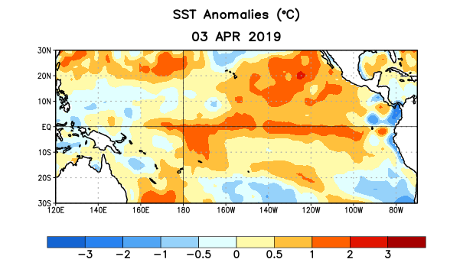
Figure 1. Average sea surface temperature (SST) anomalies (°C) for the week centered on 3 April 2019. Anomalies are computed with respect to the 1981-2010 base period weekly means.

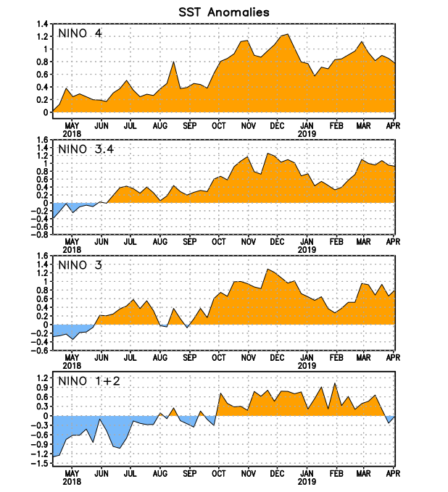
Figure 2. Time series of area-averaged sea surface temperature (SST) anomalies (°C) in the Niño regions [Niño-1+2 (0°-10°S, 90°W-80°W), Niño-3 (5°N-5°S, 150°W-90°W), Niño-3.4 (5°N-5°S, 170°W-120°W), Niño-4 (5ºN-5ºS , 150ºW-160ºE)]. SST anomalies are departures from the 1981-2010 base period weekly means.
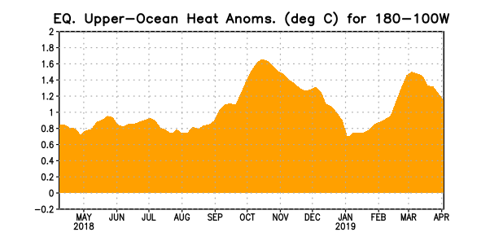
Figure 3. Area-averaged upper-ocean heat content anomaly (°C) in the equatorial Pacific (5°N-5°S, 180º-100ºW). The heat content anomaly is computed as the departure from the 1981-2010 base period pentad means.

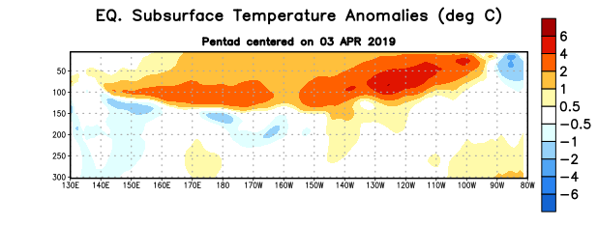
Figure 4. Depth-longitude section of equatorial Pacific upper-ocean (0-300m) temperature anomalies (°C) centered on the pentad of 3 April 2019. Anomalies are departures from the 1981-2010 base period pentad means.

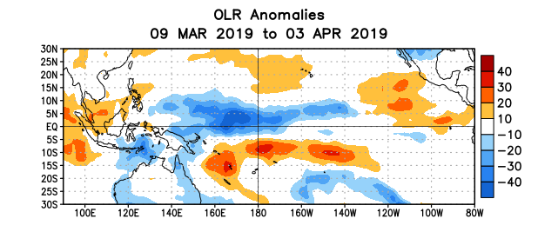
Figure 5. Average outgoing longwave radiation (OLR) anomalies (W/m²) for the period 9 March – 3 April 2019. OLR anomalies are computed as departures from the 1981-2010 base period pentad means.
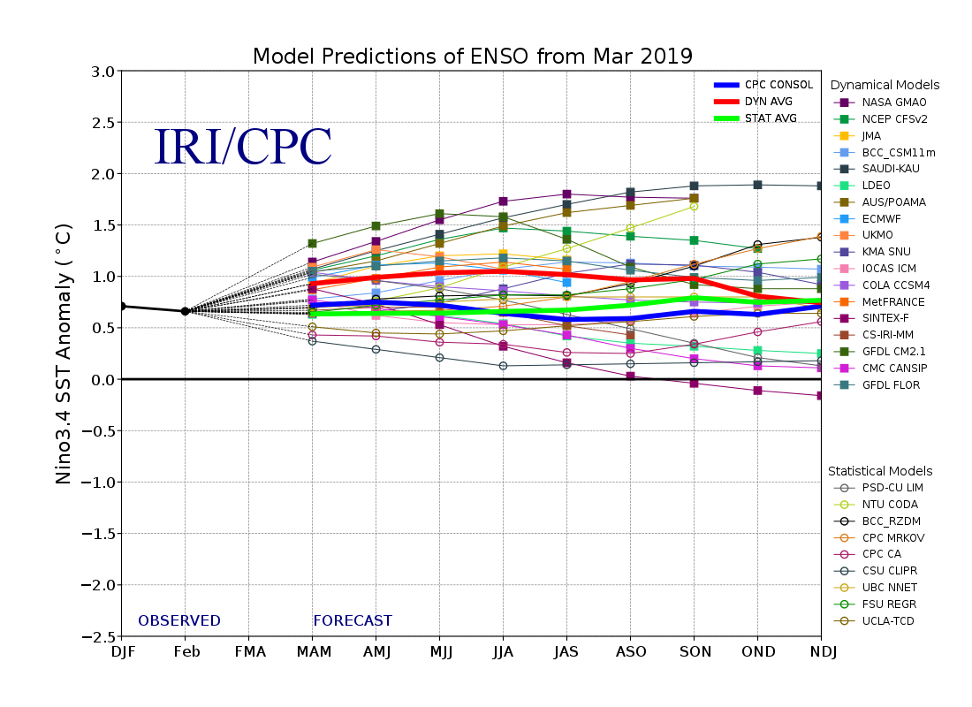
Figure 6. Forecasts of sea surface temperature (SST) anomalies for the Niño 3.4 region (5°N-5°S, 120°W-170°W). Figure updated 19 March 2019.

